**DBMS Lab : Mini Project**

Name : Urvee Ausekar

MIS : 111713007

Title of Project : Airline Reservation System

Problem Statement :

Airline Reservation System

Introduction:

* I shall implement an airline reservation system i.e a sytem with which users can book tickets of an airline.
* Mysql database will be the back end and php (with html) will be the front end.

Functional Requirements of the System :

I shall implement the following functionalities :

* When user goes to website, they have to input requirements for their flight i.e destination of flight, source of flight, date of flight , type of seat (economy or business) and round trip or single trip.
* After user enters the details and presses submit, they can see flights available.
* To book the selected flight, user has to be logged in. If they are not logged in at this stage, they should log in.
* If users don’t have an account, they should create an account.
* To create an account, user has to fill a form .
* After user is signed in, they can book a flight and go for payment.
* After payment, user will see details of booked fight .

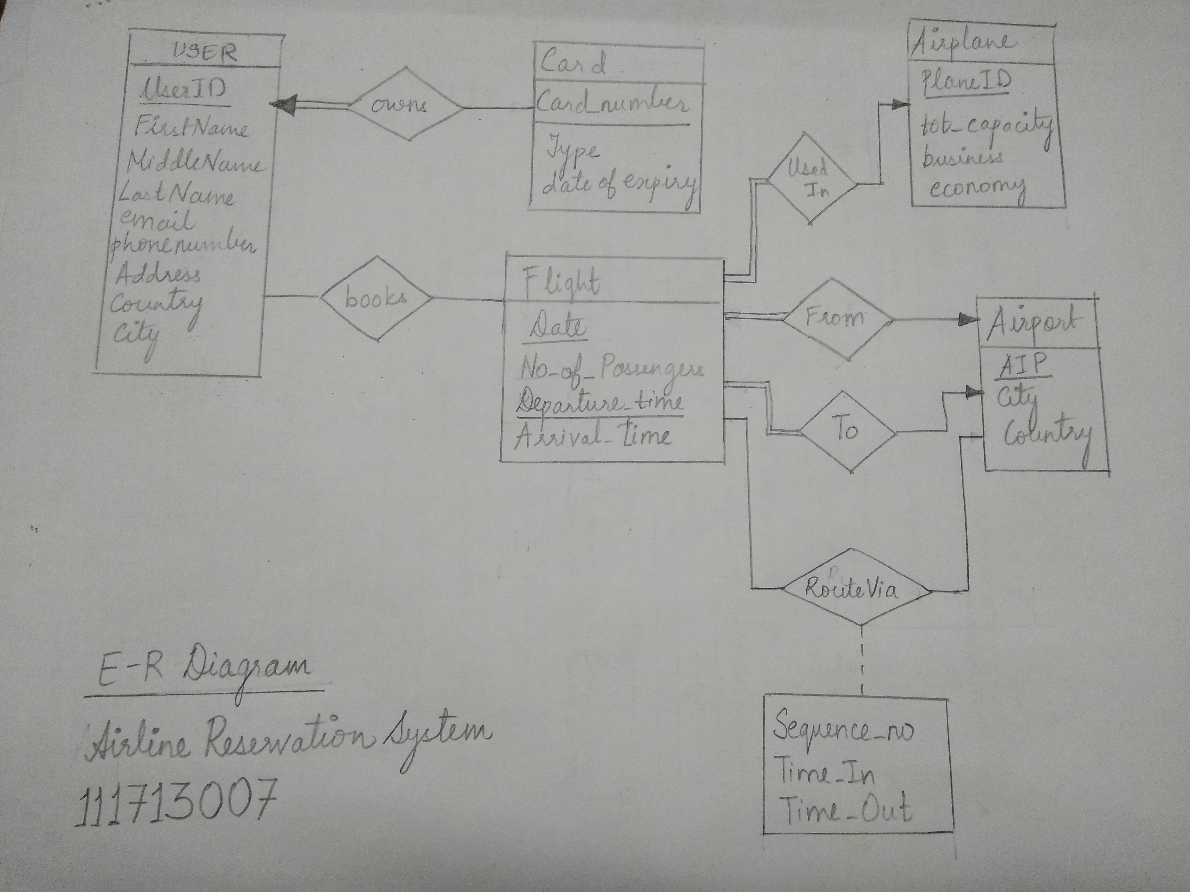

Above is the E-R diagram.

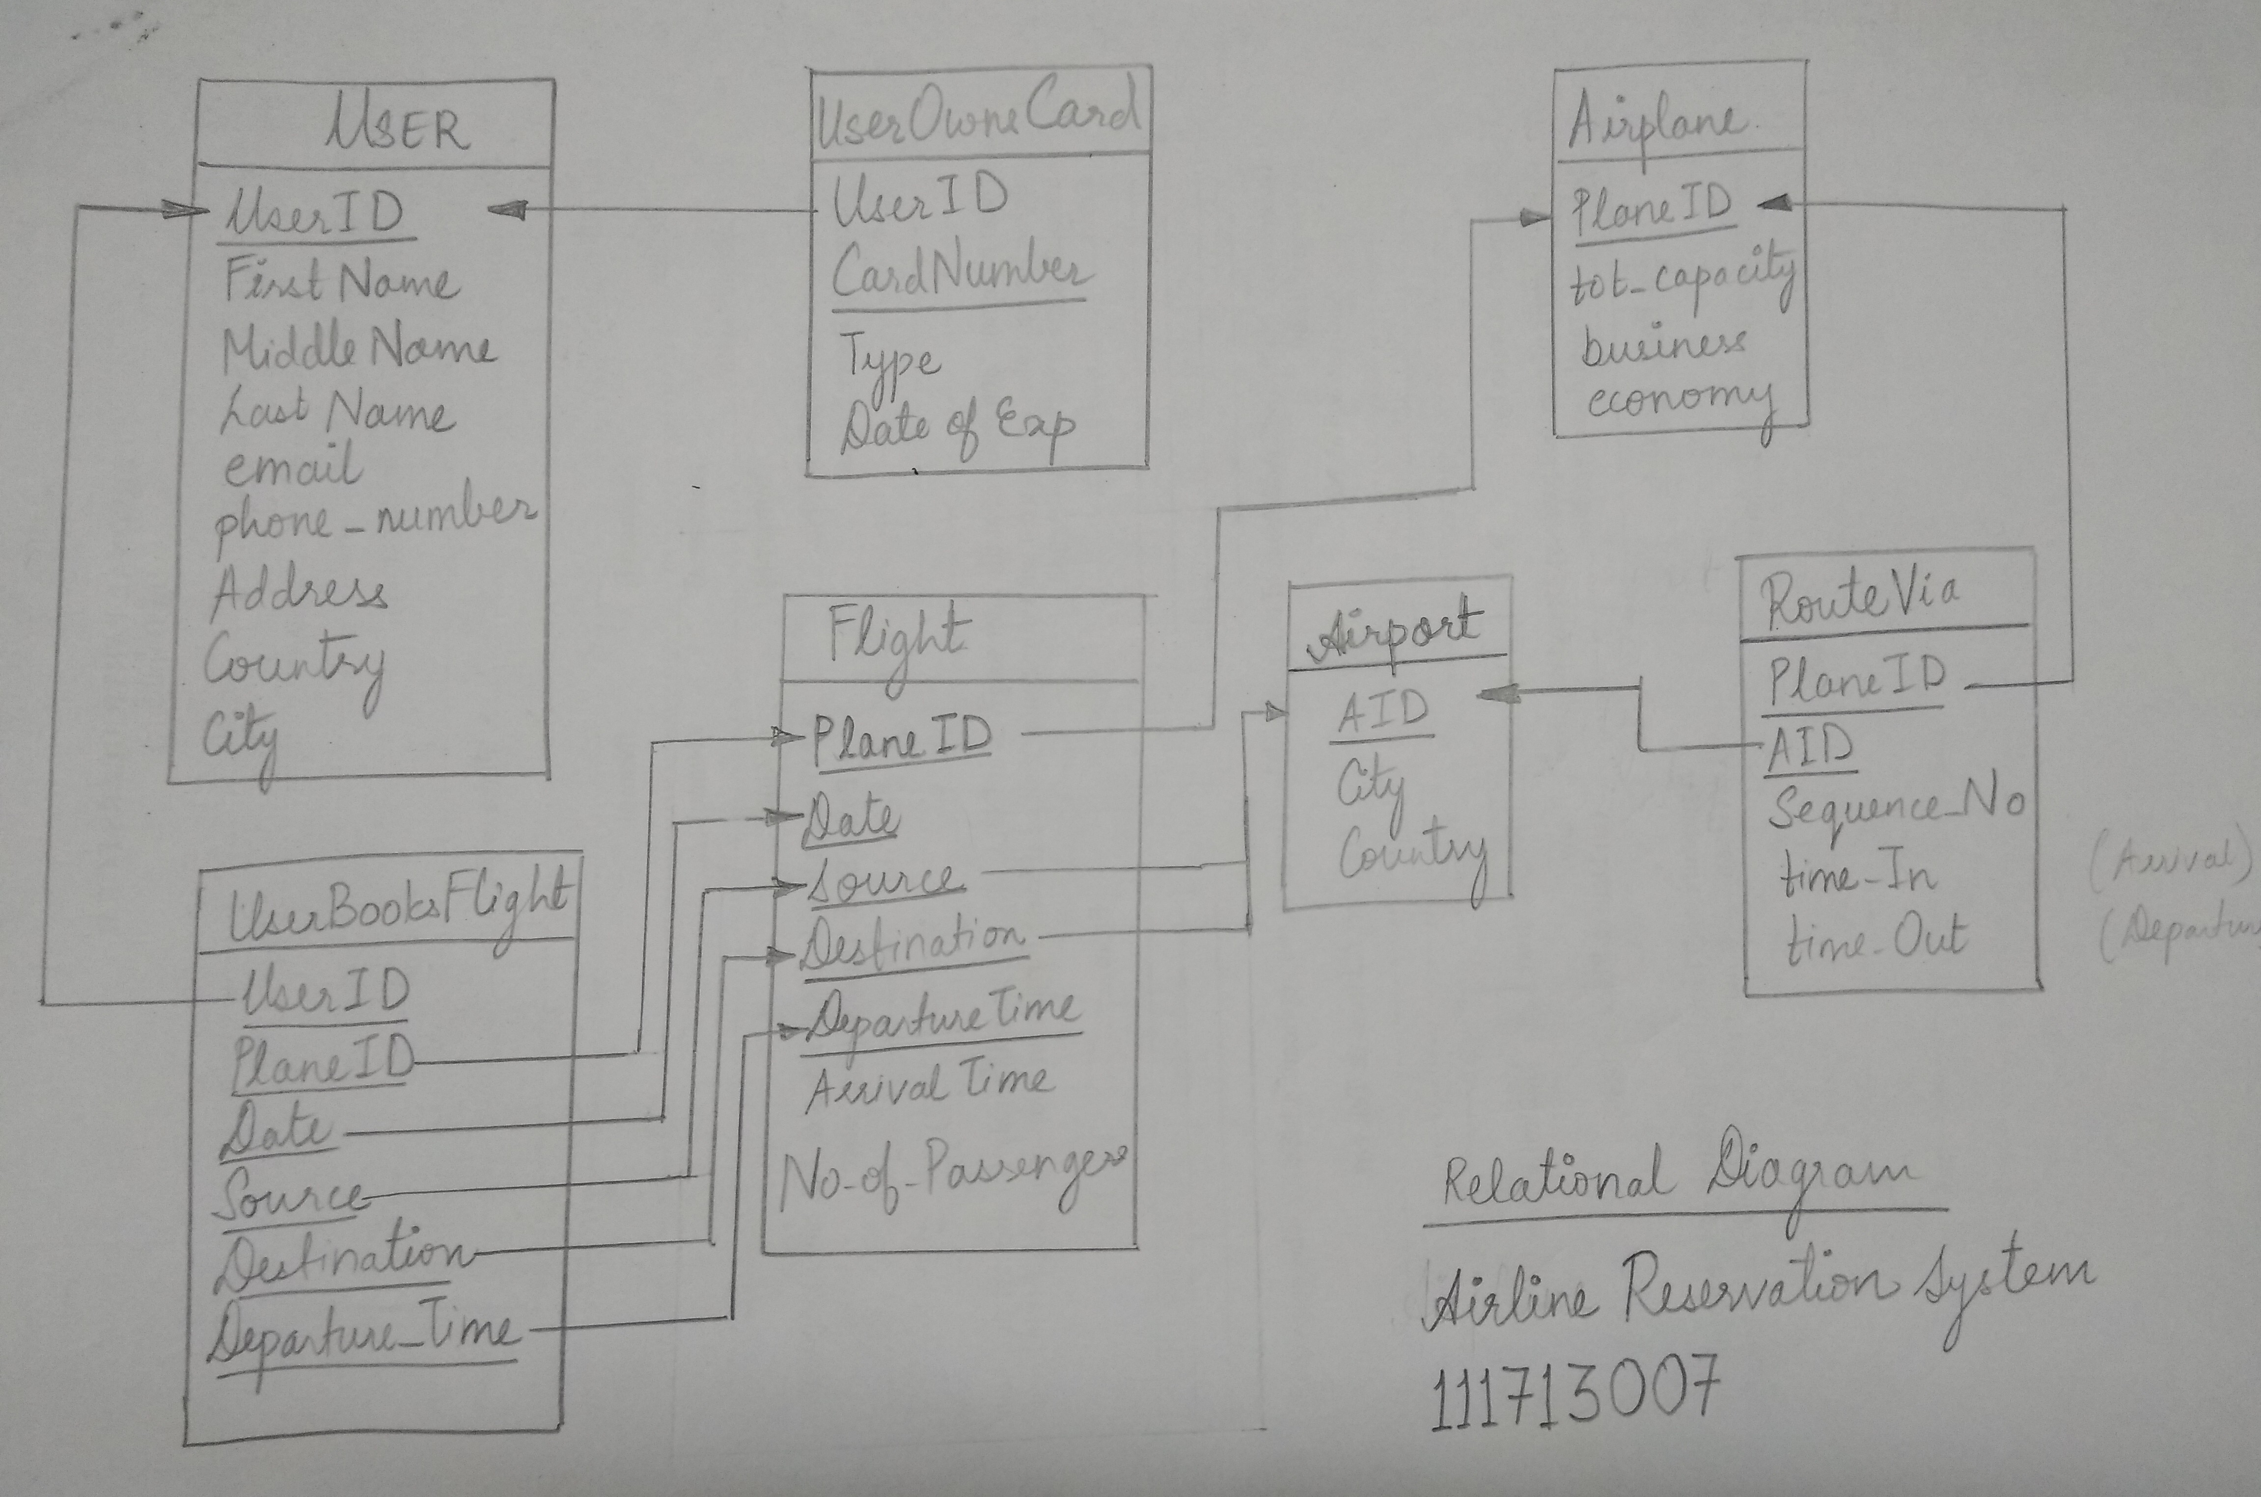

Above is the relational diagram